
MINISTRY FOR EDUCATION AND SCIENCE OF RUSSIA
________________________________

SAINT PETERSBURG ELECTROTECHNICAL UNIVERSITY

«LETI»
________________________________

Application for Delivery E-bill

PROJECT REPORT

Naveen 

Chubchik Alexander Olegovich 

Electronic & Paper

17 pages

St. Petersburg / Санкт-Петербург
2021

Index
1. Project Subject and Description 03
2. RESULTS OF THE PROJECT 04
3. KEY MILESTONES AND ACTUAL DATES OF PROJECT IMPLEMENTATION 14
4. FINAL PROJECT METRICS 16
5. project risks 16
6.. personal results 17

7. LESSONS LEARNED………………………………………………………………………….…….18

8. SUMMARY……………………………………………………………………………………………..18

9. Acknowledgement………….…………………………………………………………………… 19

- Project Subject and Description
Development is carried out on the basis of the requirements for the course work in the discipline "Software Engineering".
Full name of the project :“Application for Delivery E-bill”
Short name of the program (nick-name, 4-5 characters) _____ E-bill
In this project we developed an android application for the Delivery boy.
Using this application delivery boy first do registration, after the Registration Delivery boy will get an email with confirmation of the account. When Delivery boy confirm the account using email after that he can log in.
After Login Delivery boy will get E-bill of the ordered items with Name, contact no and Address.
After the delivery, delivery boy click on the Delivered button and in our database we shall get the confirmation of the Delivery with customer Name and contact number.
The software product is intended to development of android application for the Delivery E-bill. Using this application Delivery boy will not need any bill slip on paper .So we can save our tree as we know papers are prepared with trees.

2. RESULTS OF THE PROJECT
Delivery boy Registration:
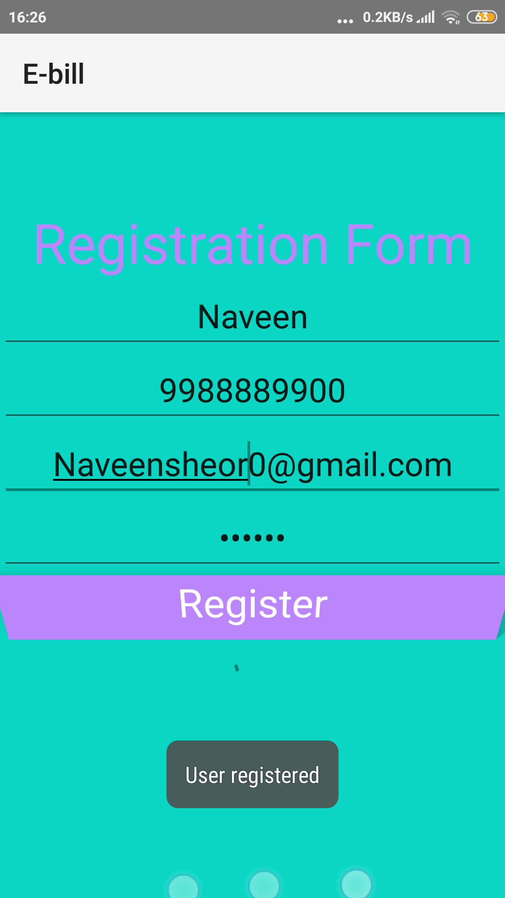
For Registration User will Provide:-
Name
Mobile number
Email id
Password
After successfully registration all user data stored in Firebase Database

If User already Registered :
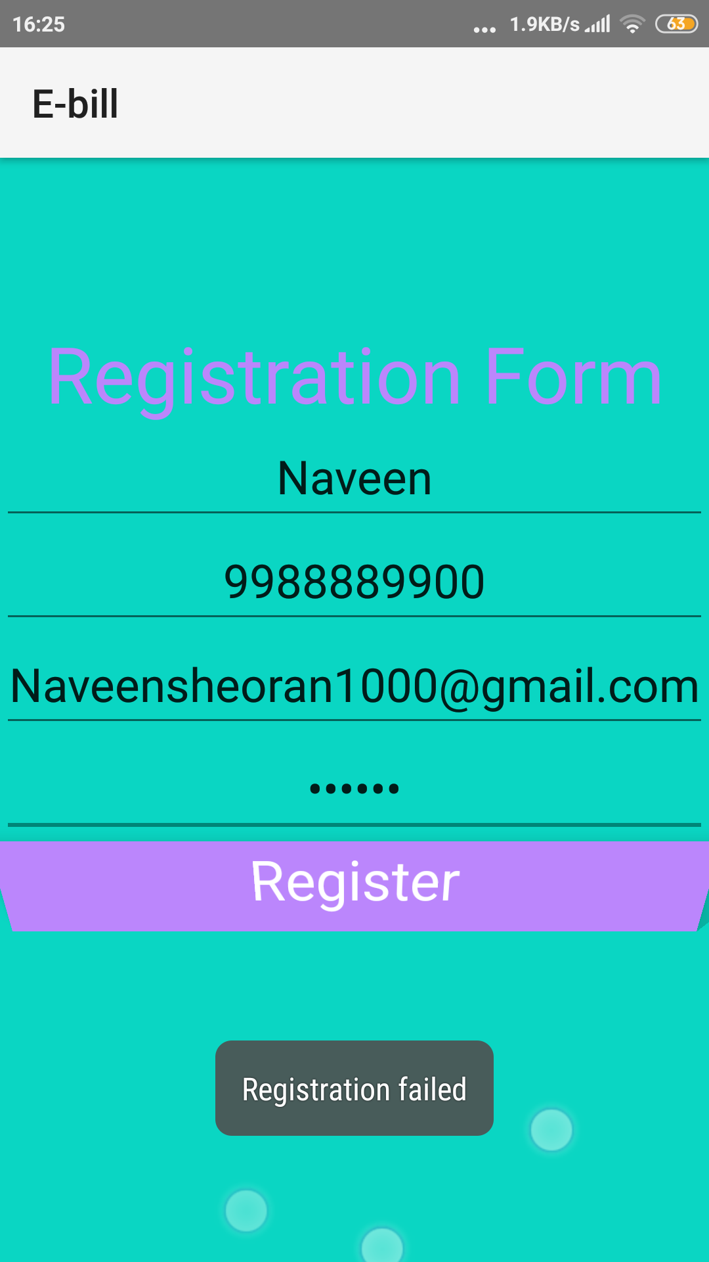

Delivery boy details stored in Database :-
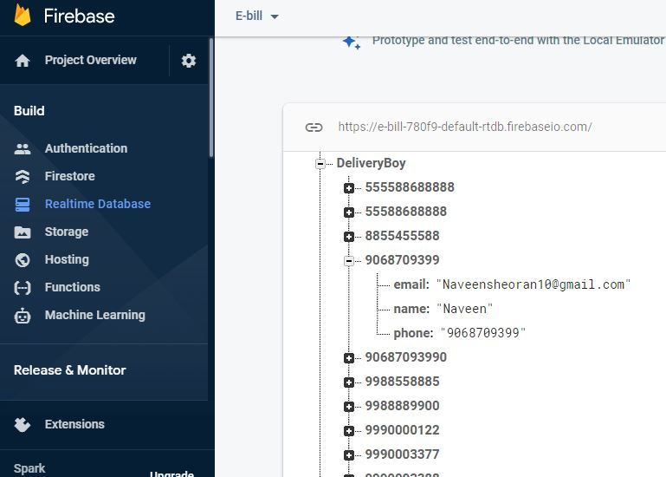

First time log in:
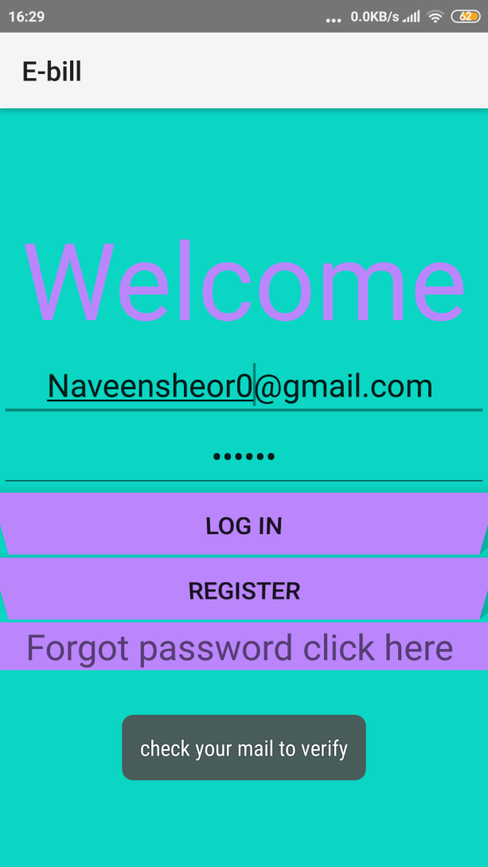

Email authentication:
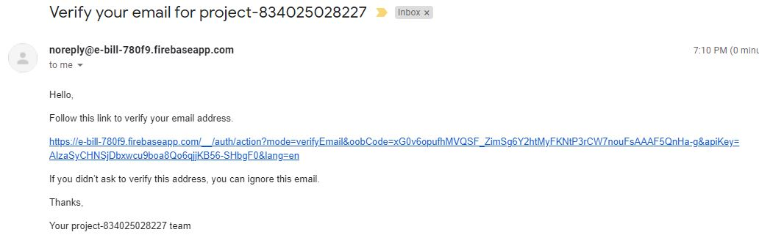

After Email verified:

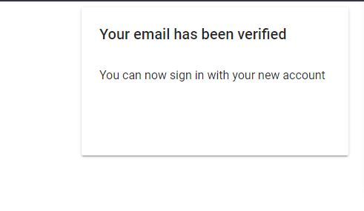

If forgot password:

Click on the forgot password link:

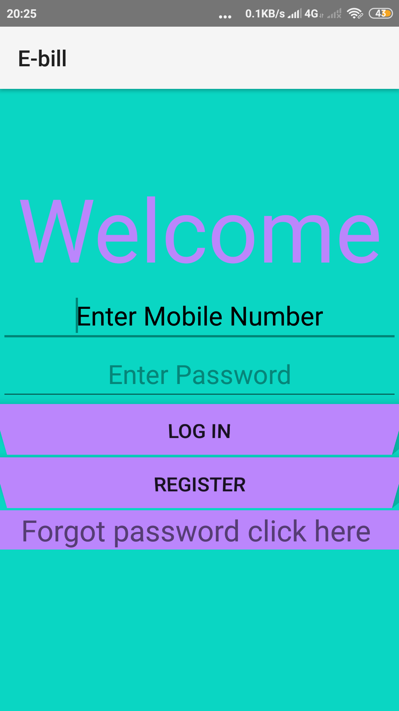

After click on forgot password link new activity will open:

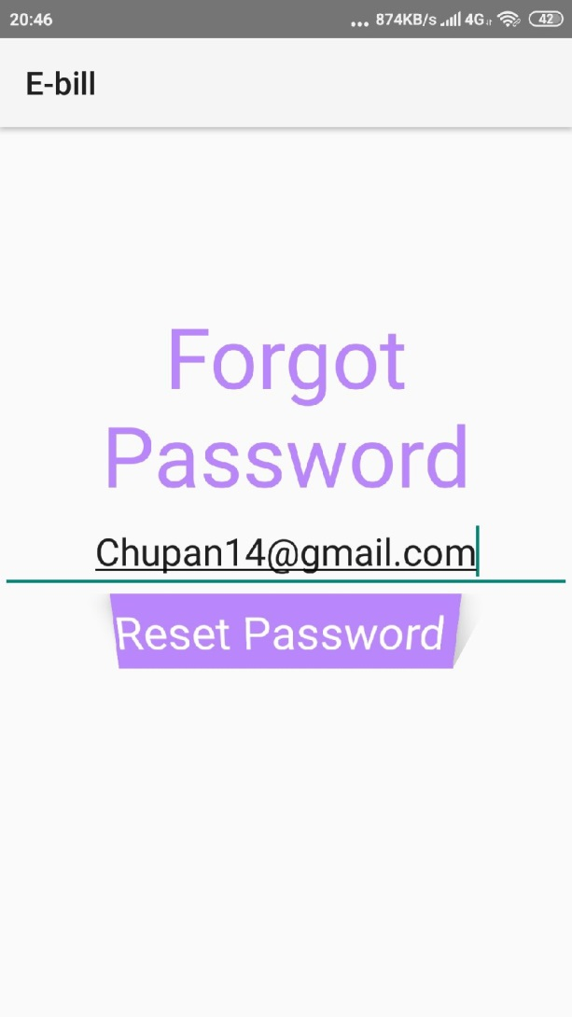

Reset password email

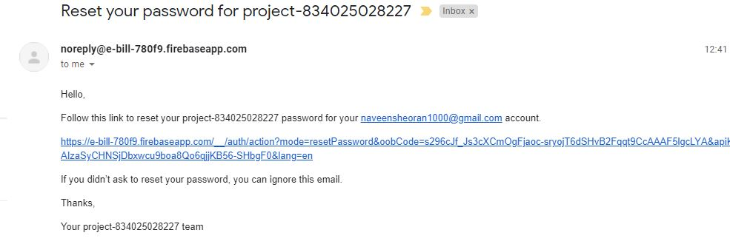

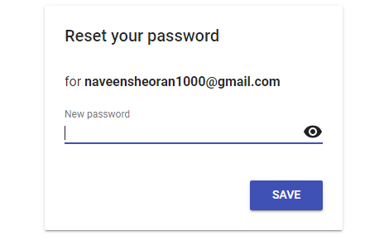

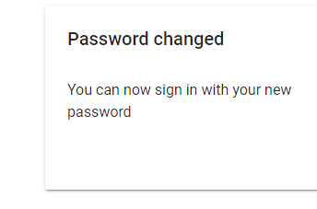

Log in Credentials checking:

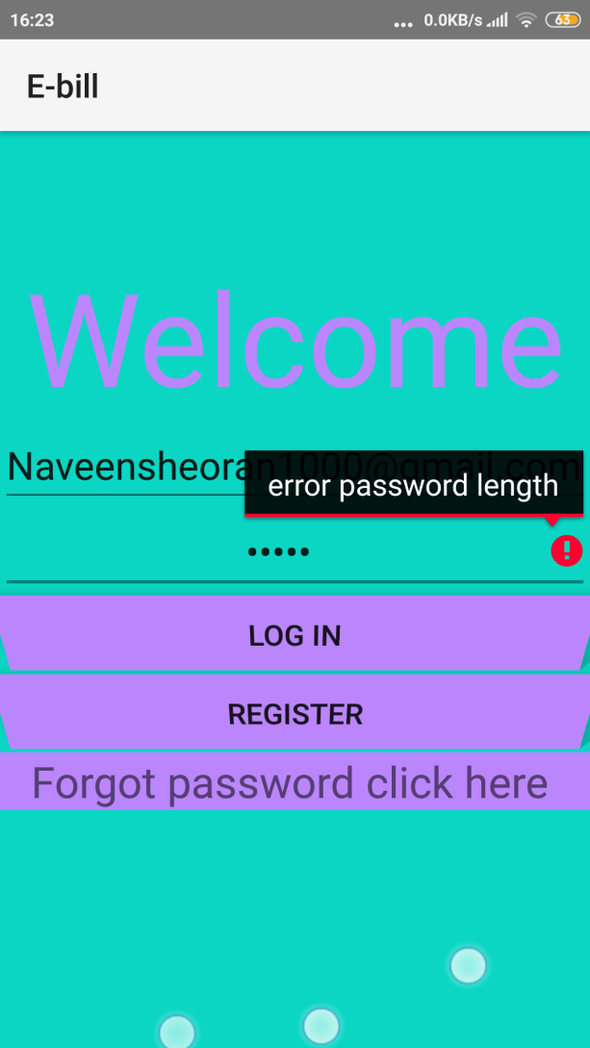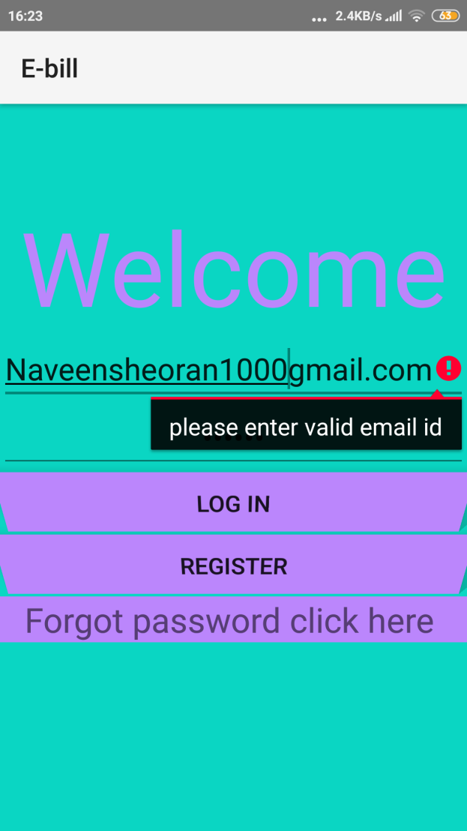

After Successful log in:

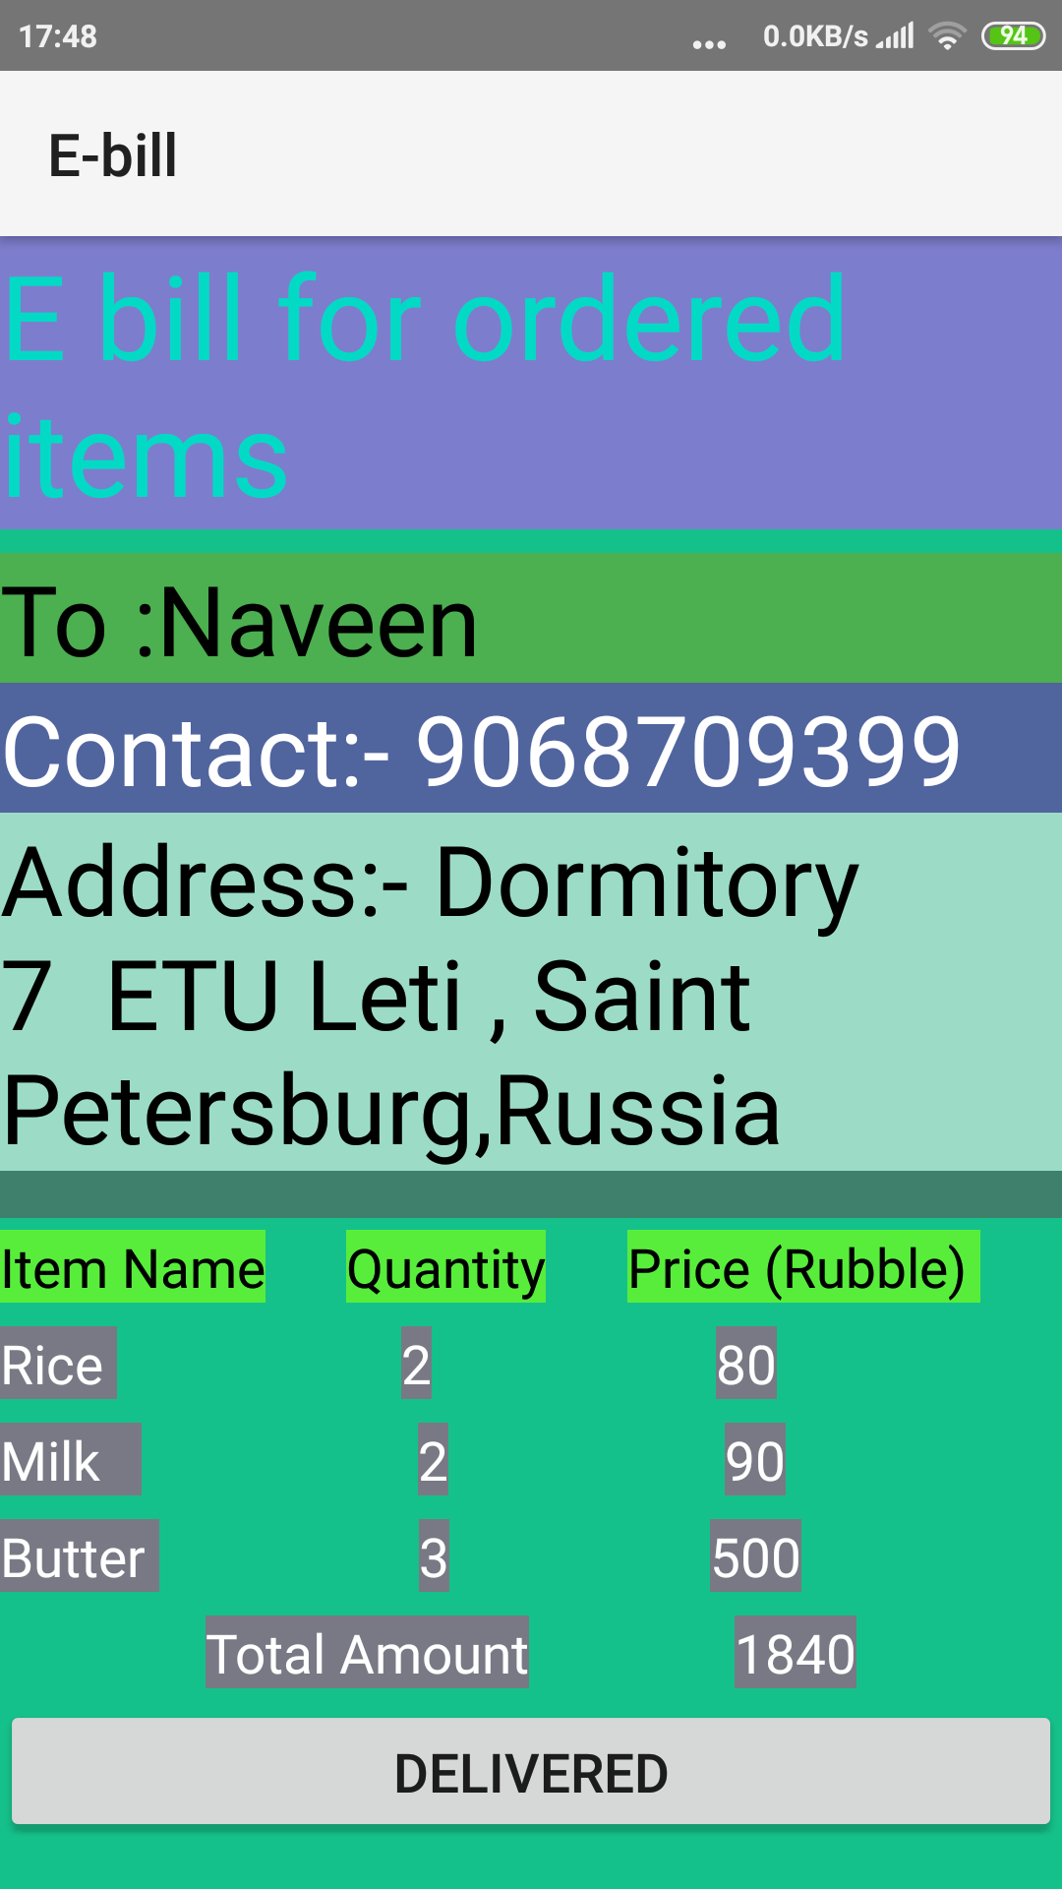

Delivery Confirmation on Click the DELIVERED BUTTON:

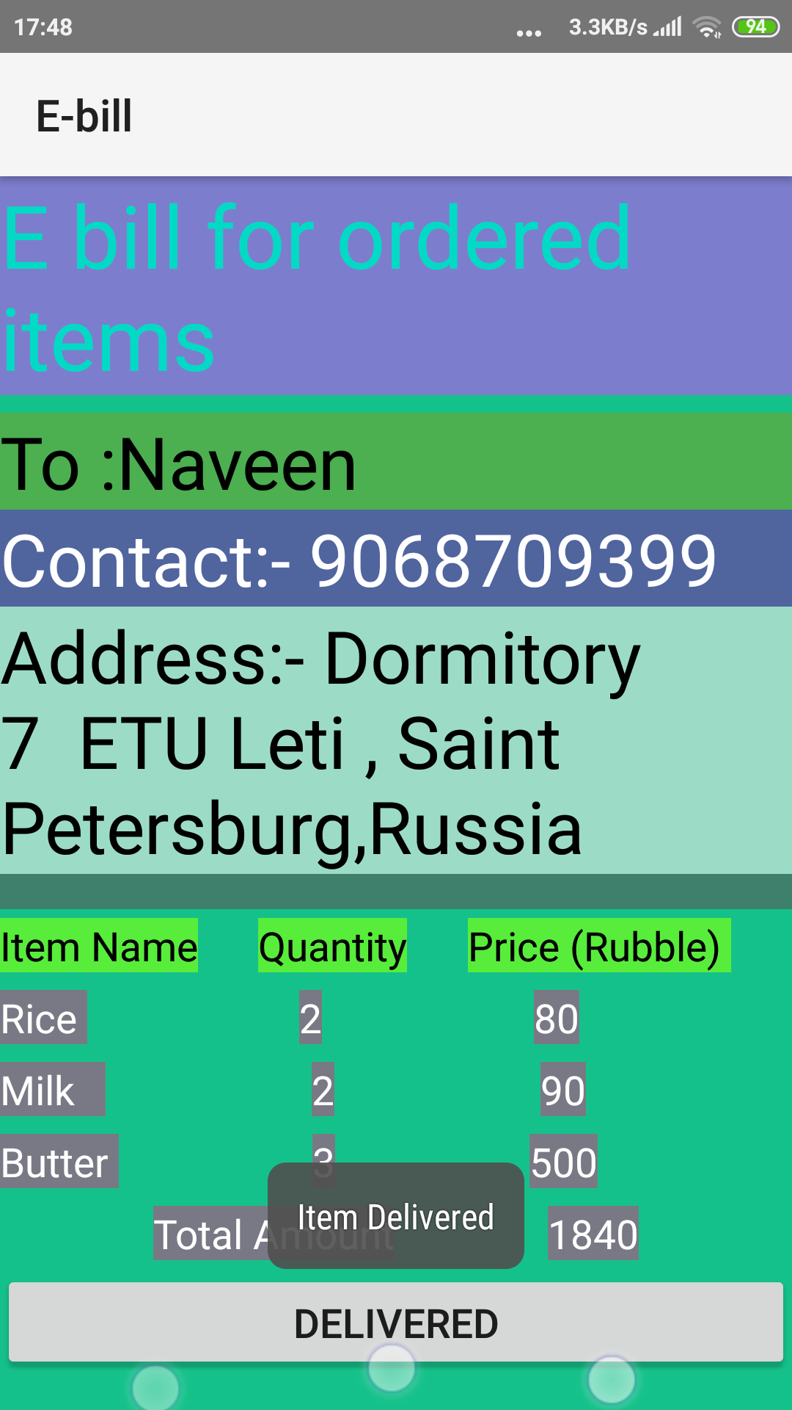

CONFIRMATION IN DATABASE:

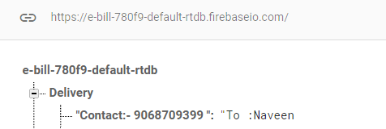

Key milstones :-
Table 1. Key milestones
№ | Start date / | End date | Description
1 | 05.02.21 | 03.03.21 | SOW developed, reviewed and signed
2 | 03.03.21 | 18.03.21 | Project Management Plan(PMP)
3 | 18.03.21 | 22.04.21 | Project Implementation – Phase 1
 | 31.03.21 | 14.04.21 | Authentication ,Registration
 | 14.04.21 | 22.04.21 | Real time Database
4 | 22.04.21 | 26.05.21 | Project Implementation – Phase 2
 | 23.04.21 | 07.05.21 | Forgot password ,new Design
 | 07.05.21 | 26.05.21 | Getting bill format , Delivery confirmation
5 | 26.05.21 | 02.06.21 | Course project completed, presentation and final report prepared for defense

ACTUAL DATES OF PROJECT IMPLEMENTATION
 | Actual
<Task/Milestone> | DD-MM-YYYY
Kick of Meeting | 27-02-21
SOW | 27-02-21
PMP | 24-03-21
Authentication Registration | 14-04-21
Real time Database | 22-04-21
Email Verification | 06-05-21
Bill Format | 14-05-21
Delivery Confirmation | 21-05-21

Configuration and change management :-

Version control system:-
For our project we used Github to store the code and other documents.
“ link https://github.com/naveenpardeep/Delivery-boy-e-bill “

FINAL PROJECT METRICS:

Reference : T04_E-Bill_Product_Metrics_2021

Link “ https://github.com/naveenpardeep/Delivery-boy-e-bill/blob/main/Files%20Doc/T04_E-Bill__Product_Metrics_2021.xls “

Project risks

Our team created a risk register with following details:-
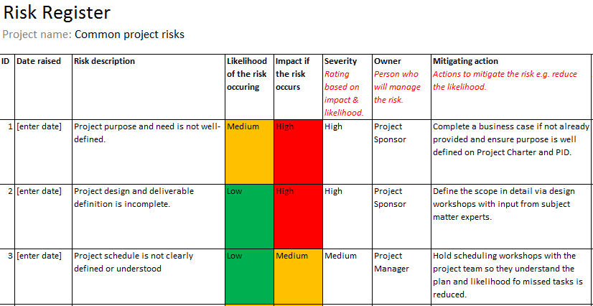

Personal results:

Naveen:-

Coding in java

XML design

Email verification

Userlogin method

Checked correct mail id format , mobile etc

Authentication

E-bill

Delivery Confirmation

Chubchik Alexander:-

Usability testing

Functional testing

Debug reports

Password change method

6. Lessons learned:-

During this project we learned a lots of new technologies in the field of Software engineering subject and in android development.

In the Software engineering subject we learned how to work in team which is most important part while working in any IT company.

We learned how to manage the work within deadline. Most important learned lesson was the test plans and coordination of the team members in the project.
Worked in a proper manner, with Key Milestones, and communications with the project team, Traced the progress of the project.

In software engineering lab sessions we learned how we can detect the faces of object using machine learning like cat and dog.

In this project we learned different new credential checking of the user’s input data.
Authentication of the user’s details, Learned new java coding with Firebase.
Like how we can store the data in the Firebase Database in real time. We Learned how we can retrieve the data from the Firebase database using the android coding in Java.
We learned different style of XML design .Like how we can design the user interface with the different Layout , Linear Layout , Relative Layout and many others.
Different testing techniques for debugging the android application.

During the project we learned that how we can store the project codes and files on Github with all team members. Using Github how to send pull request and commit the request.
Using this we can access our project’s details anywhere and without loss of the data if any team member’s System crashed or any fault then team member can access stored data on Github.

Summary

During the Software Engineering classes we developed android application for the Delivery Boy . In future we want to add some more functionality in this application like real time tracking of the Delivery boy. We want to add some more function like Customers also can use the same application for the order of food items .

Acknowledgement

I would like to express my deepest appreciation to all those who provided me the possibility to complete this report. I wish to express my sincere gratitude to my supervisor Dr. Evgeny Philippov, for his patience, interest, insightful comments, practical advice and unceasing ideas that have always helped me enormously in my project and writing of this project report. Without his support and guidance, this project would not have been possible. I could not have imagined having a better supervisor in my study.

